Test Cases

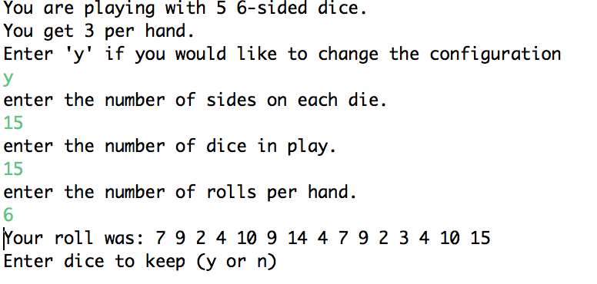

-Changing the game configuration

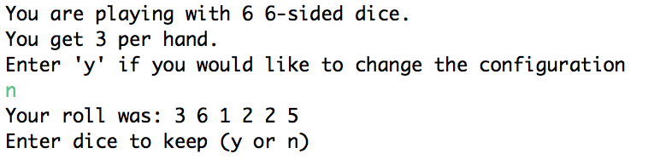

-Not Changing the game configuration

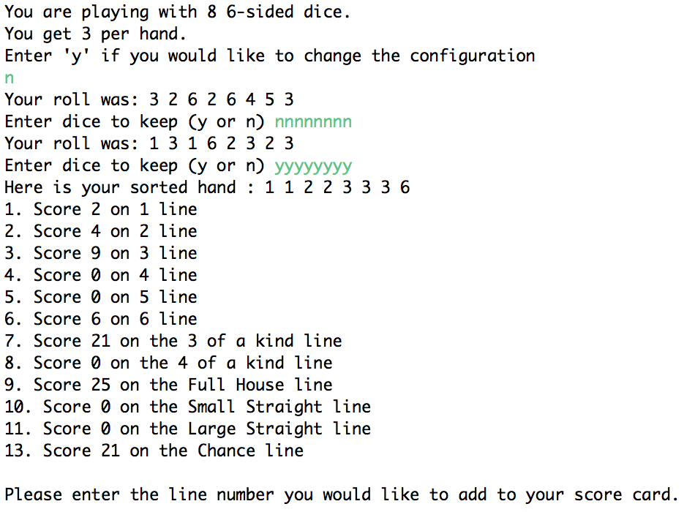

-Full house with 8 dice

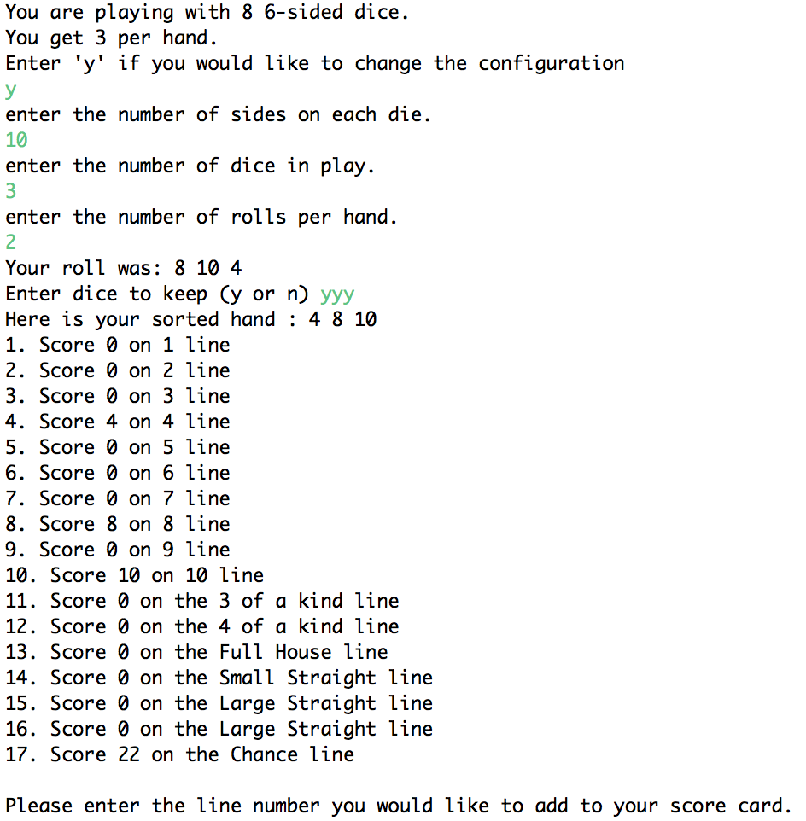

-Upper score card extension when there are more than 6 sides on the dice

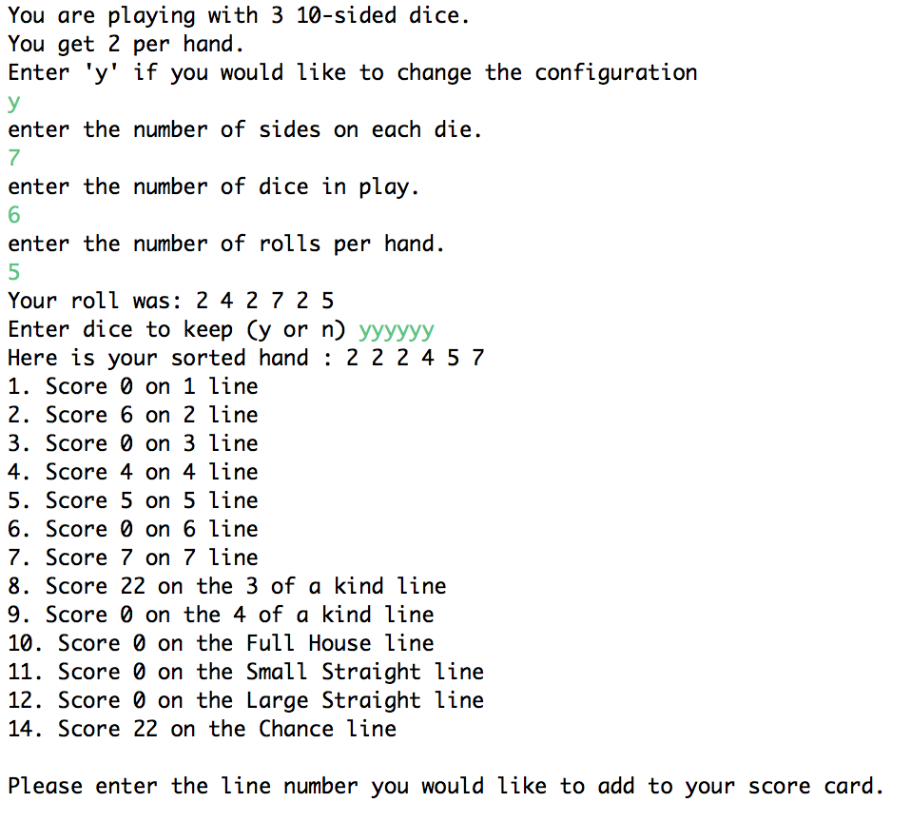

-Rather than running out of rolls, the scorecard is displayed when the user keeps all dice

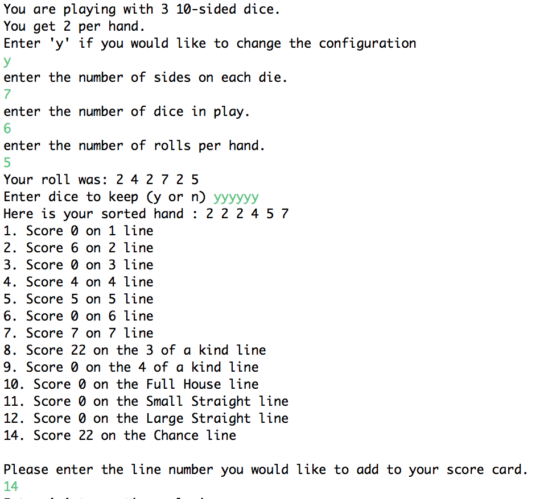

-Asking the user which line they would like to keep

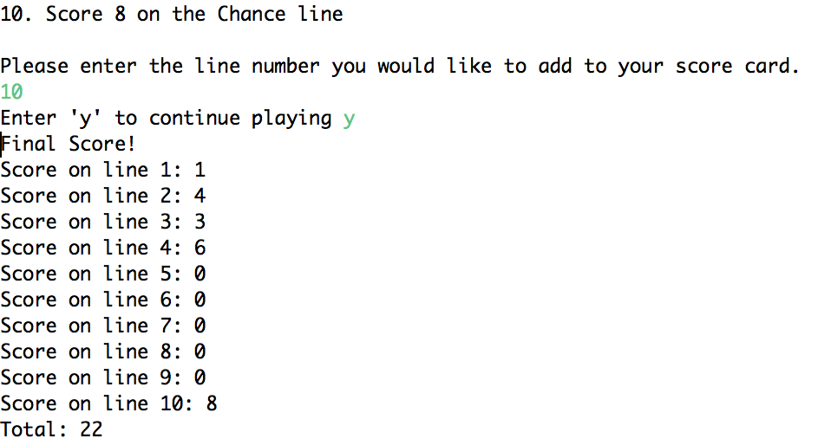

-displaying the final score card